**Mongodb Assignment Day1**

Inserting data to movies collection

use mongo_practice

db.movies.insertMany([

{title: 'Fight Club',writer: 'Chuck Palahniuko',year: 1999,actors:['Brad Pitt,Edward Norton']},

{title: 'Pulp Fiction',writer:'Quentin Tarantino',year: 1994,actors: ['John Travolta',Uma Thurman']},

{title:'Inglorious Basterds',writer:'Quentin Tarantino,year:2009,actors:['Brad Pitt','Diane Kruger','Eli Roth']},

{title:'The Hobbit An Unexpected Journey',writer: 'J R R Tolkein',year:2012,franchise: 'The Hobbit'},

])

db.movies.insertMany([

{title:'The Hobbit The Desolation of Smaug',writer: J R R Tolkein,year:2013,franchise: 'The Hobbit'},

{title:'The Hobbit The Battle of the Five Armies',writer:'J R R Tolkein',year:2012,franchise:'The Hobbit',

synopsis: 'Bilbo and company are forced to engage in a war against an array of combatants and keep

the lonely Mountain from falling into the hands of a rising darkness'},

{title: 'Pee We Hermans Big Adventure'},

{title: 'Avatar'}

])

Find querys

Q1

db.movies.find().pretty()

Q2

db.movies.find({writer:”Quentin Tarantino”).pretty

Q3

db.movies.find({actors:”Brad pitt”}).pretty()

Q4

db.movies.find({franchise:“Hobbit”}).pretty()

Q5

db.movies.find({year:{$and;[{$gte:1990,$lte:1999}]}}).pretty()

Q6

db.movies.find({year:{$and:[{$gt:2010,$lt:2000}]}}).pretty()

Update commands

db.movies.update({title: 'The Hobbit The Desolation of Smaug'},{$set: {synopsis: 'The dwarves,along with Bilbo Baggins and Gandalf the Grey continue their quest to reclaim Erebor their homeland from Smaug Bilbo Baggins is in possesion of a mysterious and magical ring'}})

WriteResult({ "nMatched" : 1, "nUpserted" : 0, "nModified" : 1 })

MongoDB Enterprise atlas-blsyrp-shard-0:PRIMARY> db.movies.findOneAndUpdate({title: 'Pulp Fiction'},{$set: {actors: ['John Travolta','Uma Thurman','Samuel L Jackson']}})

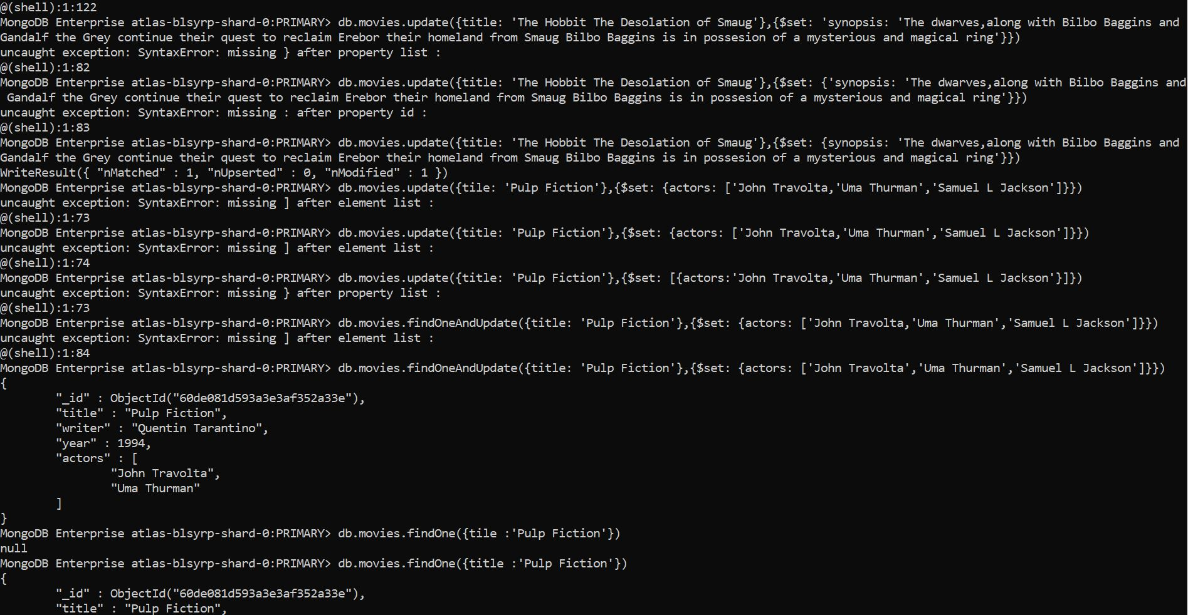

Text search

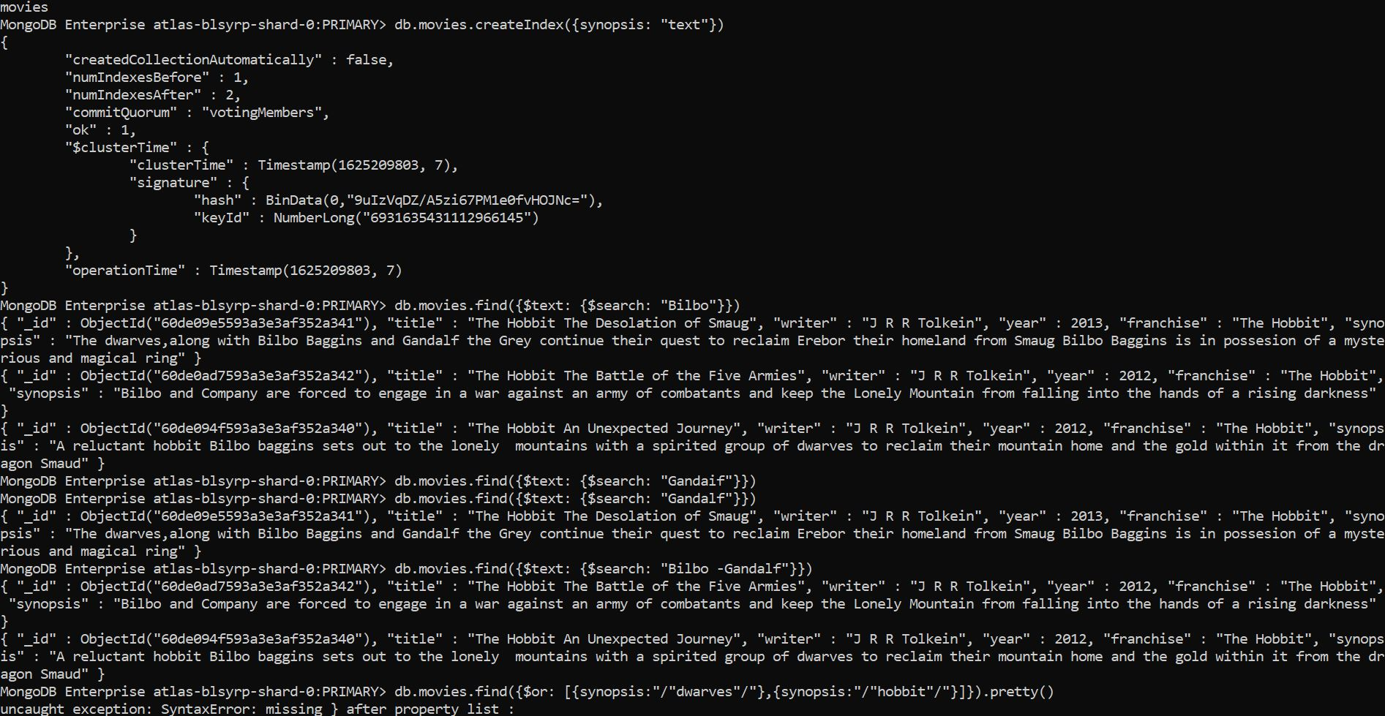

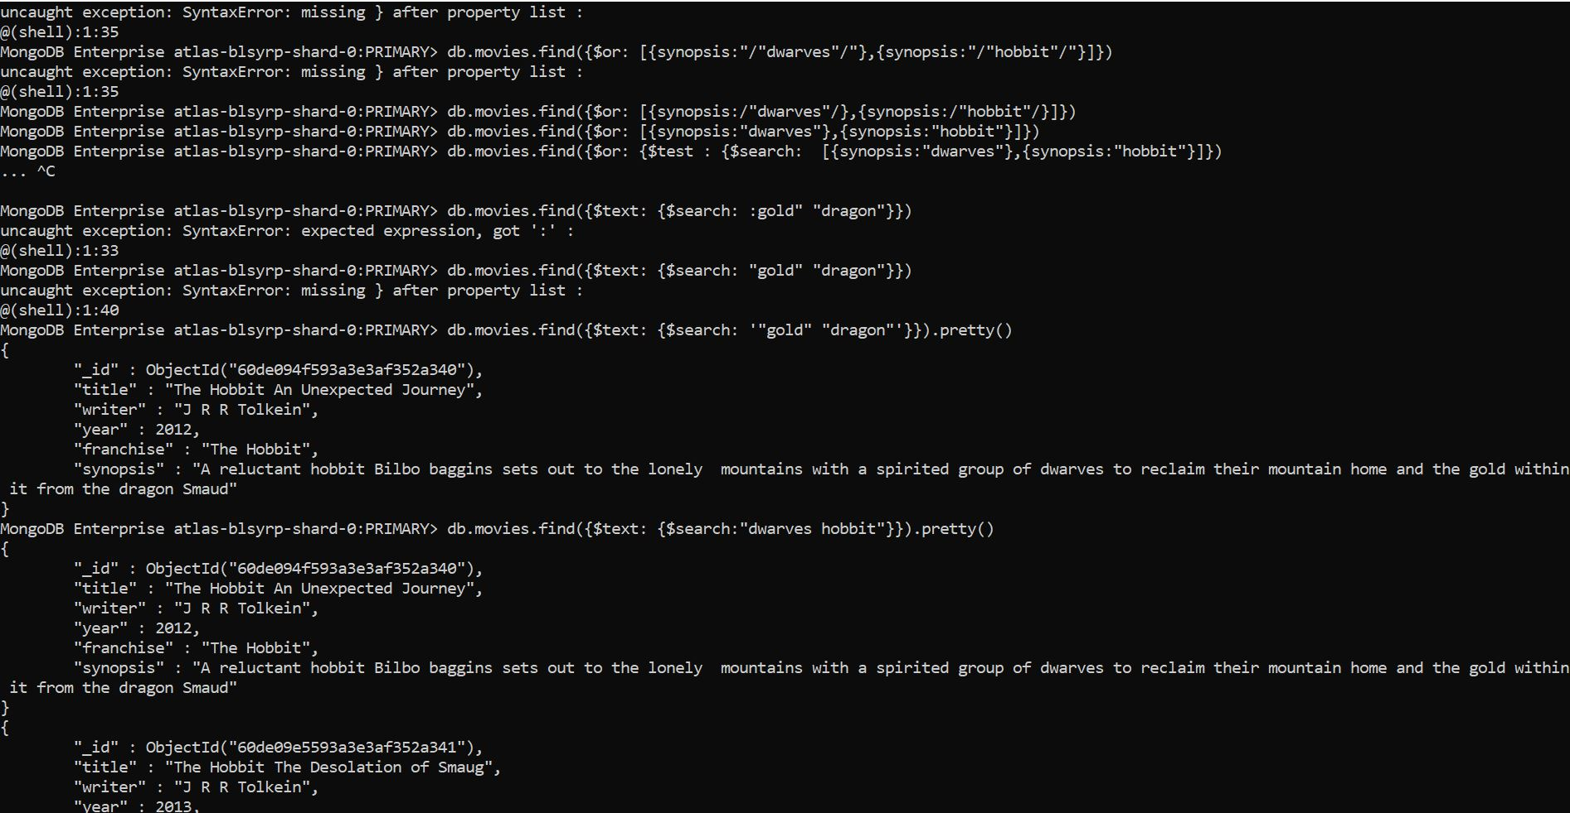

**Deleting and Relationship**



